H.T No
Regulations:
A17

Sreenidhi Institute of Science and Technology
(An Autonomous Institution)
Code No: 6C407 Date: 06-Aug-2024 (FN)

B.Tech II-Year II- Semester External Examination, Aug - 2023 (Supplementary)
Electronic Circuit Analysis (ECE and ECM)

Time: 3 Hours Max.Marks:75

Note: a) No additional answer sheets will be provided.
b) All sub-parts of a question must be answered at one place only, otherwise it will not be valued.
c) Missing data can be assumed suitably.

Bloom's Cognitive Levels of Learning (BCLL)

Remember | L1 | Apply | L3 | Evaluate | L5
Understand | L2 | Analyze | L4 | Create | L6

Part - A Max.Marks:25
Answer all QUESTIONS

 |  | BCLL | CO(s) | Marks
1 | Draw the hybrid π equivalent circuit of the bipolar transistor. | L1 | CO1 | [2M]
2 | Why common drain amplifier is called source follower? | L2 | CO2 | [2M]
3 | How negative feedback effects on the noise sensitivity? | L3 | CO3 | [2M]
4 | State the Barkhausen criterion | L1 | CO4 | [2M]
5 | Differentiate harmonic distortion and crossover distortion. | L4 | CO5 | [2M]
6 | What are the applications of tuned amplifiers? | L1 | CO6 | [3M]
7 | Find the maximum value of g_{m} for FET with I_{DSS}=10mA, V_{p}=-2V, V_{GS}=5V? | L5 | CO1 | [3M]
8 | The closed loop gain of a feedback amplifier when A= 2000 is A_{f} = 125. What is the value of β? | L5 | CO3 | [3M]
9 | What are the factors to be considered in designing the power amplifier? | L3 | CO6 | [3M]
10 | Why tuned amplifier cannot be used at low frequency? | L2 | CO4 | [3M]
Part – B Max.Marks:50
ANSWER ANY FIVE QUESTIONS. EACH QUESTION CARRIES 10 MARKS.

 |  |  | BCLL | CO(s) | Marks
11. | a) | Draw the hybrid-π equivalent circuit of the BJT at high frequency in CE configuration. Explain the significance of each parameter. | L2 | CO1 | [5M]
 | b) | Draw and explain about cascade amplifier. | L2 | CO1 | [5M]
12. | a) | Derive an expression for voltage gain of common drain amplifier. | L5 | CO2 | [5M]
 | b) | Draw the block diagram of 2-stage RC coupled JFET amplifier. | L2 | CO2 | [5M]
13. | a) | The voltage feedback shunt input FET amplifier shown has the following parameters: g_{fs} = 5 × 10^{–3} ʊ, r_{d} = 20kΩ, R_{D} = 5kΩ, R_{F} = 50kΩ, R_{G} = 100kΩ, and R_{s} = 5kΩ. Determine  (i) A_{vf} (ii) R_{if}. (iii R_{of}. Assume that C_{S} acts as an ac short.  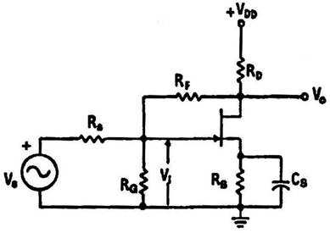 | L5 | CO3 | [5M]
 | b) | Derive the expressions for input impedance and output impedance of voltage series feedback amplifier. | L4 | CO3 | [5M]
14. |  | What is the principle of oscillation of crystals? Sketch equivalent circuit and impedance frequency graph of crystals and obtain its series and parallel resonant frequency. | L1 | CO4 | [10M]
15. | a) | Derive an expression for conversion efficiency of a class-B power amplifier in pushpull configuration. | L4 | CO5 | [5M]
 | b) | Show that the maximum collector efficiency of class-A amplifier is 50%. | L3 | CO5 | [5M]
16. | a) | Draw and explain the operation of single tuned inductively coupled tuned amplifier. | L1 | CO6 | [5M]
 | b) | Explain the significance of stagger tuned amplifiers. | L2 | CO6 | [5M]
17. | a) | Find the voltage gain for the given cascaded amplifier.  Assume h_{ie} = 1 KΩ, h_{fe} = 50, h_{re} ≈h_{oe} = 0 for each transistor.  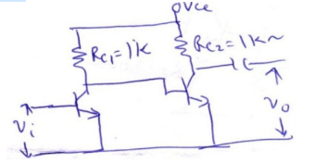 | L5 | CO1 | [4M]
 | b) | What is thermal runaway? Explain. | L1 | CO2 | [3M]
 | c) | Explain the effect of negative feedback on gain sensitivity. | L2 | CO3 | [3M]
18. | a) | What is the condition for oscillations? | L1 | CO4 | [4M]
 | b) | Calculate the second harmonic distortion, if the output signal waveform of a class A amplifier has measured values V_{CEmin} = 1V, V_{CEmax} = 24V and V_{CEQ} = 14v | L5 | CO5 | [3M]
 | c) | What is the expression for bandwidth of n stage amplifier. | L2 | CO6 | [3M]

-- 00 -- 00 –

